<https://gallery.technet.microsoft.com/office/SharePoint-Grant-a-user-to-93a73e84>

# SharePoint: Grant a user to the full control user policy with PowerShell

You can grant a SharePoint user full control access to the user policy of a given web application using PowerShell with this script. This script can also be used to grant readonly permissions as well.

**DownloadAddFullControlToAccount.ps1**

You can grant a user full control access to the user policy of a given web application using PowerShell with this script.  This script uses the following variables:

* **$webApplicationUrl** - URL of the web application to grant the user access
* **$account** - account of the user to grant access in domain\user format
* **$roleName** - name of the role to grant access (i.e.: "FullControl")

You can also grant different role types such as "FullRead", "DenyAll", or "DenyWrite" permissions as defined in [SPPolicyRoleType](http://msdn.microsoft.com/en-us/library/office/microsoft.sharepoint.administration.sppolicyroletype(v=office.15).aspx).  For example use "FullRead" to grant you search crawl account readonly access.

$webAppURL = "http://server"

$account = "domain\user"

$roleName = "FullControl"

$webApplication = Get-SPWebApplication -Identity $webAppURL

$account = (New-SPClaimsPrincipal -identity $account -identitytype 1).ToEncodedString()

$zonePolicies = $webApplication.ZonePolicies("Default")

$policy = $zonePolicies.Add($account, $account)

$role = $webApplication.PolicyRoles.GetSpecialRole($roleName)

$policy.PolicyRoleBindings.Add($role)

$webApplication.Update()

https://gallery.technet.microsoft.com/office/SharePoint-Grant-a-user-to-93a73e84

<https://www.sharepointdiary.com/2016/09/powershell-to-add-administrator-grant-permission-to-service-application.html>

# How to Add Administrator and Grant Permission to Service Applications using PowerShell?

[September 24, 2016](https://www.sharepointdiary.com/2016/09/powershell-to-add-administrator-grant-permission-to-service-application.html)

By default, Farm administrators group has rights to manage all service applications. Often there are situations when you may need to add additional administrators or grant permissions to SharePoint service applications. Say,

* You want to delegate service application administration to other users
* SharePoint farm admin account isn't added as service application administrator or not having permission to the service application.

SharePoint allows us to delegate permissions and distribute administration of Service applications to multiple users by granting access as either Service Application Administrator or Feature administrator.

These service application administrators cannot create/delete any service application but they can perform actions within their service application that doesn't affects the farm. E.g. A Search service application administrator can make any change to the Search service application, But He/She cannot make changes to the Search topology.

## Add Service Application Administrator in SharePoint 2016?

To add a  Service Application administrator, navigate to:

SharePoint 2016 Central Admin >> Manage Service Applications

From the list of available Service Applications, select the target service application such as "Managed Metadata service application" by clicking the respective row.

[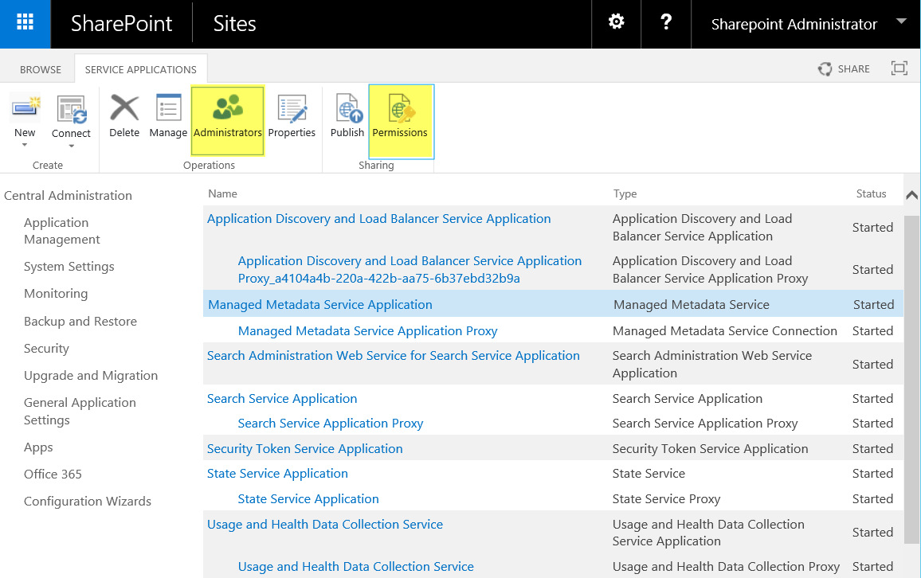](https://2.bp.blogspot.com/-uRdUat1Yhsk/WcewoHEIDrI/AAAAAAAANH4/wDrb3GaWrfku1Vjqlz-BgtMIjmH2ZPvswCEwYBhgL/s1600/sharepoint%2B2016%2Bservice%2Bapplication%2Bpermission%252C%2Badministrator.png)

In the Ribbon click on "Administrators" button. Enter the user name that you wish to have admin rights to SharePoint service application >> Click on "Add" button.

From the permissions section, select "Full Control". Commit your changes by clicking the OK button.